ELEC 2210 LABORATORY REPORT COVER PAGE

Complete and attach this page to the front of your lab report.

Meeting # 002 EXPERIMENT 3: Medium Scale Integrated (MSI) Circuits *Title of Lab Experiment*

Student Name: Howard Jacob, A

*Name (Last, First, MI)*

Student Email: JAH0147

*AU 7-character username*

GTA: Jonathan

*Name of your GTA*

The section you are enrolled in: (Circle One): 1 2 3 4 5 6 7 8

Date experiment performed (dd / mm / yy): 2/9/20

Date report submitted: (dd / mm / yy): 8/9/20

If you performed this experiment at a time other than your regularly scheduled section meeting:

Section # of the section you sat in on (Circle One): 1 2 3 4 5 6 7 8 Makeup

Name of the GTA who supervised your work: None

I hereby certify that the contents of this report are true and complete to the best of my ability. The lab work was performed by me exclusively, and this report was written by me exclusively.

Jacob Howard 9/8/20

Student signature Date signed

ELEC-2210

Digital Electronics

FROM: Jacob Howard

TO: Jonathan

DATE: 9/8/20

LAB SECTION: 001 (Tuesday, 1:00pm-2:50 pm)

EXPERIMENT 3:

Medium Scale Integrated (MSI) Circuits

# **Introduction**

# The objectives of this lab experiment were mainly focused on performing simple problems with equipment that we will be using relatively frequently. This helped us gain experience with equipment for future labs. We were introduced to multiplexers and demultiplexers and some of the things they can do. This lab required us to use the ELVIS board and some PC software later in the lab.

# **Step 1**

The lab consisted of 3 steps. The fourth step was just to clean up our station. For the first step, we had to make the necessary connections provided from a table from *Table1* below. We used the 74LS161 chip. This setup was just the first part of the full circuit design from our prelab. We were able to check if everything was wired up correctly by checking LEDs 2-0.

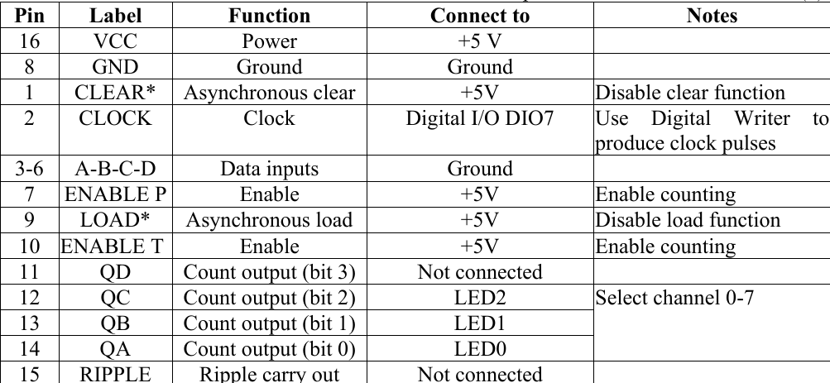

*Table 1*

# **Step 2**

For step 2 of the lab, we wired up the 74LS151 chip. This chip is an 8-input multiplexer. A table was also given in this step for how to correctly wire up the chip. The table is shown in *Table 2*. In this step, only one output is connected to an LED and we were able to use the Digital Writer to verify the correct functioning of the circuit. By changing the input in the Digital Writer we were able to verify that we had the wiring correct.

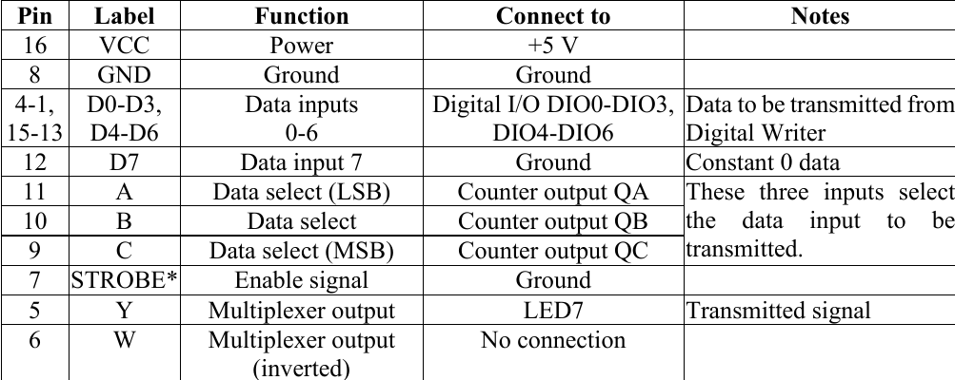

*Figure 1*

# **Step 3**

In step 3, we connected the 74LS138 chip, which is the last chip we need to be wired up for the circuit design. This chip is a decoder or demultiplexer. A wiring table was also provided for this chip. We just needed to follow the table in *Table 3* to wire up the demultiplexer correctly. We used the Digital Writer to provide inputs to the circuit. The final result was a circuit that would light the LED 0-7 depending on what the input was. The correct results are shown in *Table 4*.

|  |  |
| --- | --- |
| **Input** | **Output** |
| 1 | LED 0 turns on |
| 2 | LED 1 turns on |
| 3 | LED 2 turns on |
| 4 | LED 3 turns on |
| 5 | LED 4 turns on |
| 6 | LED 5 turns on |
| 7 | LED 6 turns on |
| 8 | LED 7 turns on |

# **Conclusion**

This experiment was a good hands-on way of showing the multiplexer and demultiplexer works. I think the lab was simple and very interesting, though I did burn up a demultiplexer chip by wiring it in upside down. I would say this is one of my favorite circuits I have wired on a breadboard and was a great intro to the chips and the software